Remote Bridge

🌍 What is a Remote Bridge?
# Source: Chatgpt (GPT‑5 Mini) at [12/18/2025]
A Remote Bridge is a type of network bridge that connects two or more LANs located in different physical locations (such as separate buildings or cities) and allows them to function as if they are part of the same local network. It works at Layer 2 of the OSI model, forwarding Ethernet frames based on MAC addresses.
✅ A Remote Bridge "bridges the distance" between two networks using a wide-area connection, such as the internet, leased lines, or VPNs.

🔄 What It Does
# Source: Chatgpt (GPT‑5 Mini) at [12/18/2025]
- Extends a LAN across geographic locations
- Forwards traffic between remote segments based on MAC addresses
- Creates a single broadcast domain across distant sites
- Typically uses tunneling (VPN, GRE, etc.) to securely carry traffic

📶 Remote Bridge Network Example
# Source: Chatgpt (GPT‑5 Mini) at [12/18/2025]
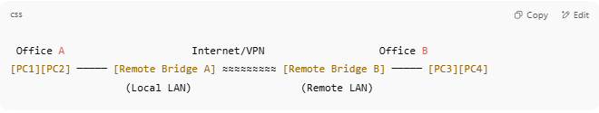

Office A Internet/VPN Office B
[PC1][PC2] ───── [Remote Bridge A] ≈≈≈≈≈≈≈≈≈ [Remote Bridge B] ───── [PC3][PC4]
(Local LAN) (Remote LAN)

- Devices in Office A and Office B communicate like they're on the same LAN, even if they're miles apart.

🧠 Technologies Used in Remote Bridging
# Source: Chatgpt (GPT‑5 Mini) at [12/18/2025]
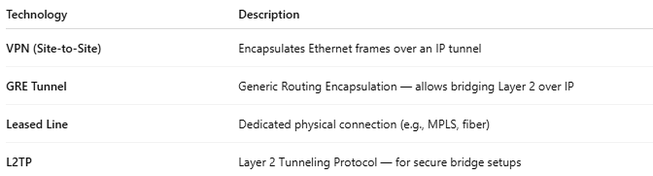

Technology | Description
VPN (Site-to-Site) | Encapsulates Ethernet frames over an IP tunnel
GRE Tunnel | Generic Routing Encapsulation — allows bridging Layer 2 over IP
Leased Line | Dedicated physical connection (e.g., MPLS, fiber)
L2TP | Layer 2 Tunneling Protocol — for secure bridge setups

🆚 Local Bridge vs Remote Bridge
# Source: Chatgpt (GPT‑5 Mini) at [12/18/2025]
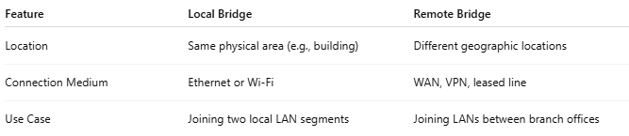

Feature | Local Bridge | Remote Bridge
Location | Same physical area (e.g., building) | Different geographic locations
Connection Medium | Ethernet or Wi-Fi | WAN, VPN, leased line
Use Case | Joining two local LAN segments | Joining LANs between branch offices

✅ Pros of Remote Bridging
# Source: Chatgpt (GPT‑5 Mini) at [12/18/2025]
- ✔️ Extends the same network across multiple sites
- ✔️ Transparent to devices — no reconfiguration needed
- ✔️ Useful for legacy systems or software that requires LAN access

❌ Cons
# Source: Chatgpt (GPT‑5 Mini) at [12/18/2025]
- ❌ Creates a single broadcast domain — may lead to congestion
- ❌ Not as scalable or efficient as routing/VPN with VLANs
- ❌ Sensitive to latency and packet loss over WAN connections
- ❌ Requires careful setup and security (e.g., encrypted tunnels)

🔧 When to Use a Remote Bridge
# Source: Chatgpt (GPT‑5 Mini) at [12/18/2025]
- You have software or equipment that only works over LAN
- You need to extend a VLAN between buildings
- You want a simple L2 connection between offices without complex routing

📌 Summary
# Source: Chatgpt (GPT‑5 Mini) at [12/18/2025]
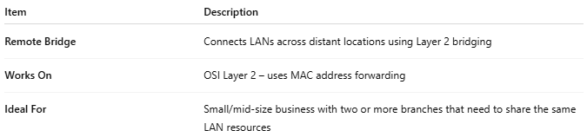
Item | Description
Remote Bridge | Connects LANs across distant locations using Layer 2 bridging
Works On | OSI Layer 2 – uses MAC address forwarding
Ideal For | Small/mid-size business with two or more branches that need to share the same LAN resources

